One Page Bio-Data
Name | Ms. Neha Rani |  |  |  |  |  |  | 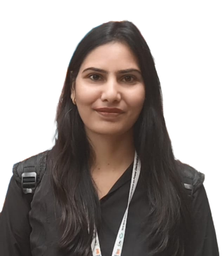
Designation | Guest Faculty (Assistant Professor)
Pay Scale | 55,500
Department | Electrical Engineering
Qualification | B.Tech, M.Tech, PhD Pursuing
Experience (in years) | Total  10 |  | Teaching  10 |  |  | Administration |  |  |  | Industry
Research Interests | Power Electronics and Control System
Contact Details: | Email  neha.sangwan8@gmail.com |  |  |  |  |  | Mobile/Phone  8684082220
Research Publications | International Journals |  |  | National Journals |  |  | International Conferences |  | National Conferences
Research Publications | 1 |  |  |  |  |  | 2
Books/Chapters Published |  | -
B.Tech Projects Guidance |  | Completed |  |  | 5 |  | In progress |  | 1
Consultancy Projects |  | Completed |  |  | - |  | In progress |  | -
Seminar/Conference/STTPs |  | Attended |  |  | 2 |  | Organized
Awards/Fellowships etc. |  | -
Additional Duties |  | ATPO (Electrical Engineering), Faculty In-Charge Conference Hall

